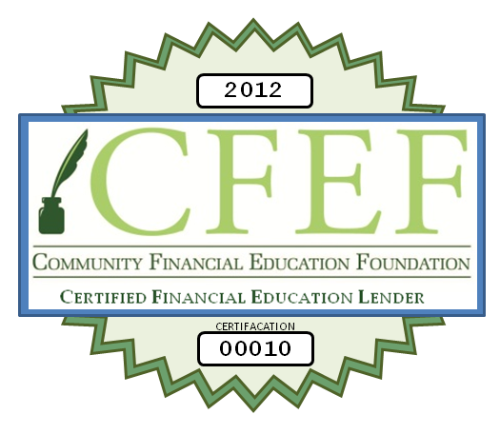

Community Financial Education Foundation’s (CFEF) Financial Education Lender Certification

Certified Financial Education Lender (“CFEL”)
Principles:

- TRANSPARENCY AND DISCLOSURE
A CFEL will comply with the disclosure requirements of the state in which their offices are located and federal disclosure requirements including the Federal Truth in Lending Act. Contracts between Partners and their customers must fully outline the terms of the transaction. Partners agree to disclose the cost of the service fee both as a dollar amount and as an annual percentage rate (“APR”) prior to funding a loan.
- PROVIDE CONSUMER FIANCIAL EDUCATION ON WEBSITE
CFELs will strive to educate consumers about the terms of their products prior to requiring a consumer executing the loan agreement. CFELs will provide customers with access to financial education information via its website and in face-to-face transactions on topics such as:
- How to obtain and understand your credit report
- How a various loan products work
- How to budget
- Importance of building an emergency fund
- How to find credit counseling
- Borrowing basics and credit management

- TRUTHFUL ADVERTISING
A CFEL will not advertise any transaction in any false, misleading, or deceptive manner, and will promote only the responsible use of its services.

- CONSUMER PRIVACY
A CFEL will have a consumer privacy policy in place to protect consumer sensitive data as well as proper notification procedures to alert consumers who data may have been compromised.
- CANCELLATION POLICY
A CFEL will give its consumers the right to rescind, at no cost, a loan transaction on or before the close of the following business day.
.

Certification process:
- Lenders who wish to participate will complete a self-assessment and application for certification along with the initial membership application fee of $1200.00
- The CFEF Review Board will review the Lender application for certification
  - CFEF Review Board consists of a small team of consumer financial educators and financial services professionals.

- If application is denied then the application fee is refunded in full along with a specific reason for decline so that applicants can address the CFEF Review Boards concerns and re-apply. Any application that is resubmitted must accompany the application fee of $1200.00. If application is denied a second time $900.00 will be refunded to the applicant and the applicant must wait 90 days before reapplying.

- If application is approved an acceptance packet will be sent to the primary applicant email contact
  - Acceptance packet will include:
    - Unique branded CEFL seal with CERTIFICATION number to be displayed on the lender’s website listed on the application only. A CFEF certified lender will be able to display the CEFL seal as long as they adhere to the above principles and practices and are subject to CFEF annual reenrollment
    - Information on how to provide hyperlinks to the www.mystartingpoint.org web portal from the approved applicant website.
    - Information on CFEF membership branded website program (link to your own branded version of www.mystartingpoint.org
    - Information on CFEF member employee services (employee education & reward programs)
    - CFEL CERTIFICATION Certificate to display in the approved applicants place of business (printable 8x10)
  - In addition, the CFEF and MyStartingPoint web portals will maintain a listing of Certified Financial Education Lenders.
  - Approved CFEF/CFEL s will be required to submit an annual self-assessment and annual $1200.00 designation fee.

Certified Financial Education Lender (“CFEL”)
Certification self-assessment
CFEL Applicant Business Name: ________________________
CFEL Applicant dba: __________________________________
CFEL Contact name: ____________________________
CFEL Contact email: ____________________________
CFEL Applicant Website(s): __________________________________
__________________________________
Does the above listed applicant comply with the disclosure requirements of the state in which their offices are located and federal disclosure requirements including the Federal Truth in Lending Act?
Yes or No (circle one)

Does the above listed applicant disclose the cost of the service fee both as a dollar amount and as an annual percentage rate (“APR”) prior to funding a loan?
Yes or No (circle one)

Does the above listed applicant provide consumer financial education on or links from the above listed website(s) and/or in face-to-face transactions?
Yes or No (circle one)

Does the above listed applicant commit to not advertise any transaction in any false, misleading, or deceptive manner, and will promote only the responsible use of its services?
Yes or No (circle one)

Do the above listed applicants have a consumer privacy policy in place and are easily accessible on its website(s)
Yes or No (circle one)

Does the above listed applicant have a Red Flags Policy or Identity theft remediation program in place?
Yes or No (circle one)

Does the above listed applicant allow consumers the right to rescind, at no cost, a loan transaction on or before the close of the following business day?
Yes or No (circle one)

I certify that the above self-assessment has been completed by an employed associate and/or acting executive of the above listed CFEL applicant Business, and that the responses to this self-assessment are truthful to the best of your knowledge.
Signed: __________________________ Printed: ________________________ Date: ________________

Certified Financial Education Lender (“CFEL”)
Application for Certification

Date of Application: ______________
Applicant Business Name: ________________________
Applicant d.b.a.: __________________________________
Contact name: ____________________________
Contact email: ____________________________
Contact Business Phone: ____________________________
Consumer Contact Phone: ____________________________
Applicant Primary address: _______________________________________ Suite: _______
City: ___________________ State: ____ Zip: _______

Applicant Consumer address: _______________________________________ Suite: _______
City: ___________________ State: ____ Zip: _______
Applicant Website(s): __________________________________
__________________________________

Applicant Endorsement
Signed: __________________________ Printed: ________________________ Date: ________________
CFEF Review Board Endorsement
Signed: __________________________ Printed: ________________________ Date: ________________

Approved: _____ CERTIFICATION number: _______________ Effective Date: __________________

Declined: _____ Reason: ________________________________________________________________

CFEF REVIEW BOARD TO COMPLETE BELOW

